## Sterschema’s

Hieronder staan de sterschema’s voor de feiten sales_target, training en order_item vermeld.

*Afbeelding 1: sterschema sales_target*

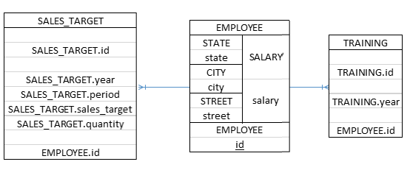

*Afbeelding 2: sterschema order_item*

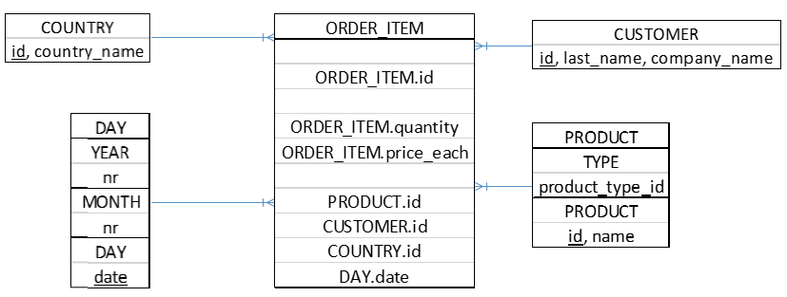

## Implementatieplan: dimensies en feitentabel

CREATE TABLE [dbo].[Country](

[country_Id] [int] NOT NULL,

[country_name] [varchar](255) NULL,

PRIMARY KEY CLUSTERED ([country_Id] ASC)

CREATE TABLE [dbo].[Customer](

[customer_Id] [int] NOT NULL,

[last_name] [varchar](255) NULL,

[company_name] [varchar](255) NULL,

PRIMARY KEY CLUSTERED ([customer_Id] ASC)

CREATE TABLE [dbo].[Employee](

[employee_id] [int] NOT NULL,

[salary] [float] NULL,

[state] [varchar](255) NULL,

[city] [varchar](255) NULL,

[street] [varchar](255) NULL,

PRIMARY KEY CLUSTERED ([employee_id] ASC)

CREATE TABLE [dbo].[Order_Item](

[order_item_Id] [int] NOT NULL,

[quantity] [int] NULL,

[price_each] [float] NULL,

[product_id] [int] NULL,

[customer_id] [int] NULL,

[country_id] [int] NULL,

[date] [date] NULL,

[retailer_id] [int] NULL,

PRIMARY KEY CLUSTERED ([order_item_Id] ASC)

CREATE TABLE [dbo].[Product](

[product_Id] [int] NOT NULL,

[product_type_id] [int] NULL,

PRIMARY KEY CLUSTERED ([product_Id] ASC)

CREATE TABLE [dbo].[Sales_Target](

[Sales_Target_Id] [int] IDENTITY(1,1) NOT NULL,

[year] [int] NULL,

[period] [int] NULL,

[sales_target] [int] NULL,

[quantity] [int] NULL,

[employee_id] [int] NULL,

[product_id] [int] NULL,

PRIMARY KEY CLUSTERED ([Sales_Target_Id] ASC)

CREATE TABLE [dbo].[Training](

[training_id] [int] NOT NULL,

[year] [int] NOT NULL,

[employee_id] [int] NOT NULL,

[emp_training_id] [nchar](10) NOT NULL,

PRIMARY KEY CLUSTERED ([emp_training_id] ASC)

ALTER TABLE [dbo].[Order_Item] ADD CONSTRAINT [ORDER_ITEM_COUNTRY_ID_FK] FOREIGN KEY ([country_id]) REFERENCES [dbo].[Country]([country_Id])

ALTER TABLE [dbo].[Order_Item] ADD CONSTRAINT [ORDER_ITEM_CUSTOMER_ID_FK] FOREIGN KEY ([customer_id]) REFERENCES [dbo].[Customer]([customer_Id])

ALTER TABLE [dbo].[Order_Item] ADD CONSTRAINT [ORDER_ITEM_PRODUCT_ID_FK] FOREIGN KEY ([product_id]) REFERENCES [dbo].[Product]([product_Id])

ALTER TABLE [dbo].[Sales_Target] ADD CONSTRAINT [SALES_TARGET_EMP_ID_FK] FOREIGN KEY ([employee_id]) REFERENCES [dbo].[Employee]([employee_id])

ALTER TABLE [dbo].[Training] ADD CONSTRAINT [TRAINING_EMP_ID_FK] FOREIGN KEY ([employee_id]) REFERENCES [dbo].[Employee]([employee_id])

## Uploadplan

Voor de migratie van de datawarehouse is gebruik gemaakt van de SSIS ETL-tool. Hieronder staan de ETL-schema’s en queries van de migratie.

*Afbeelding 3: ETL-schema migratie tabel country, employee, customer, product en sales_target*

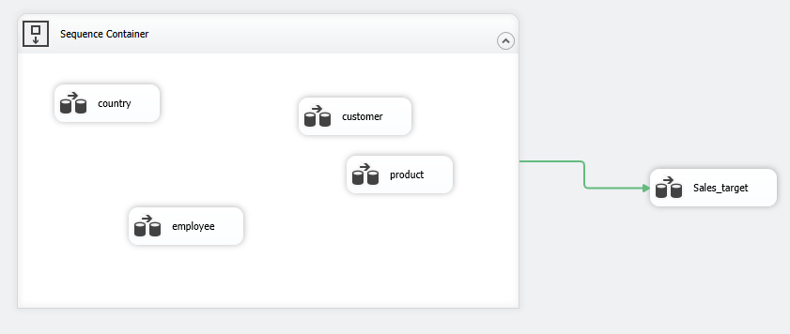

*Afbeelding 4: ETL-schema mapping country*

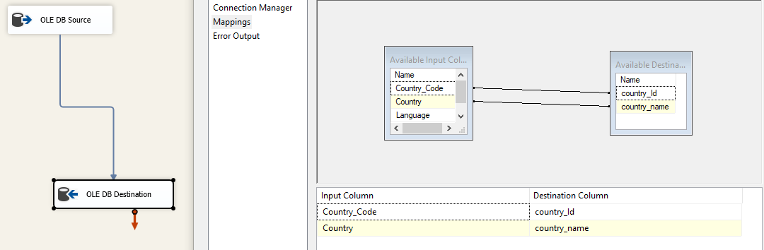

*Afbeelding 5: ETL-schema mapping customer*

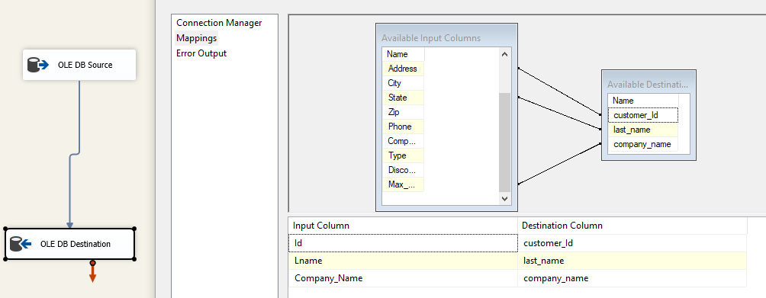

*Afbeelding 6: ETL-schema mapping product*

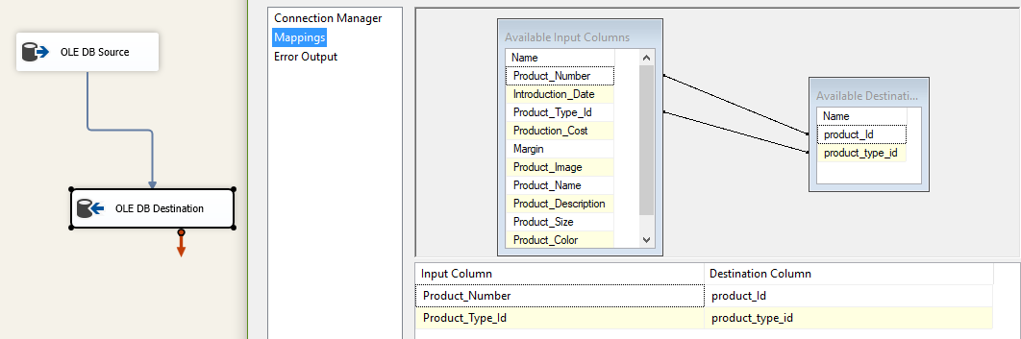

*Afbeelding 7: ETL-schema mapping employee*

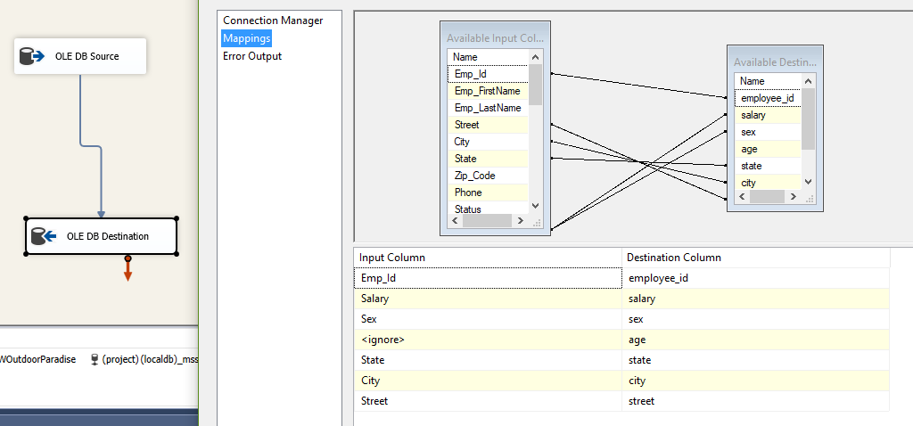

*Afbeelding 8: Mapping query migratie employee*



*Afbeelding 9: ETL-schema mapping sales_target*

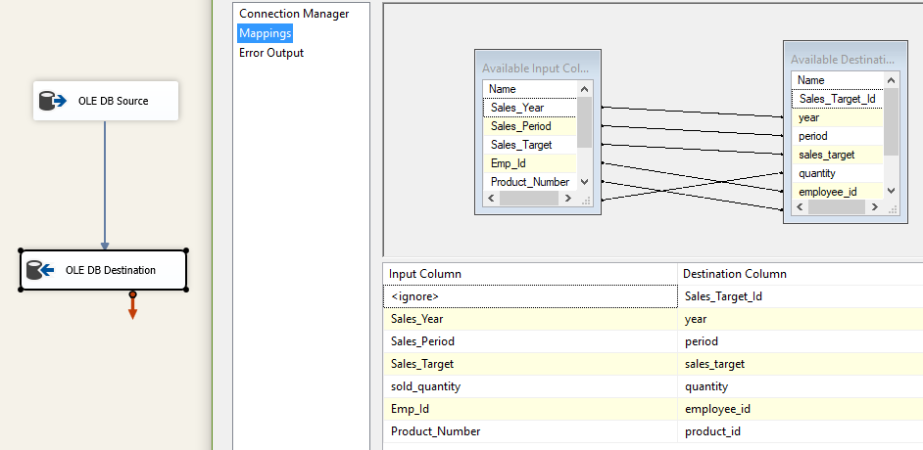

*Afbeelding 10: Mapping query sales_target*

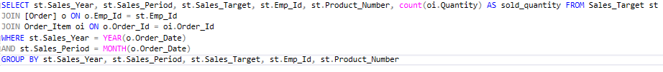

*Afbeelding 10: ETL-schema mapping training*

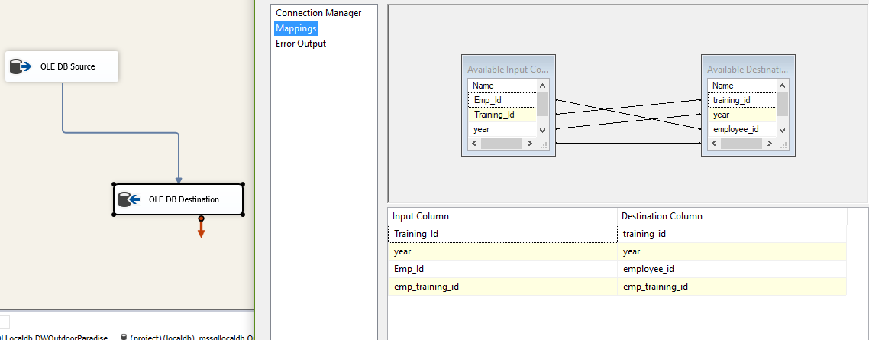

*Afbeelding 11: ETL-schema mapping order_item*

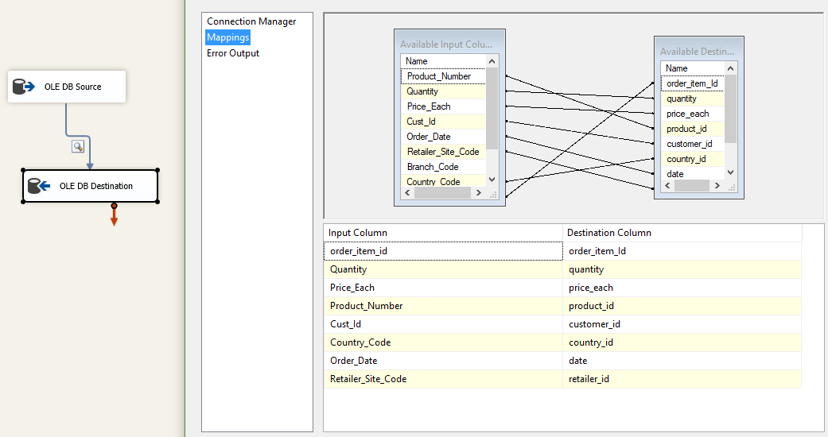

*Afbeelding 12: Mapping query migratie order_item*

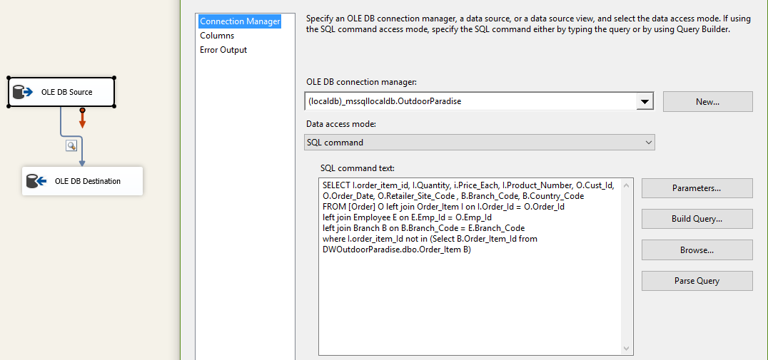

## Rapportage in SQL Server Reporting Service

Voor de rapportage van de datawarehouse is de SQL Server Reporting Service van Visual Studio gebruikt. Hieronder een aantal afbeeldingen van deze tool met de gebruikte queries.

*Afbeelding 13: Rapport 1 in SSRS tool*

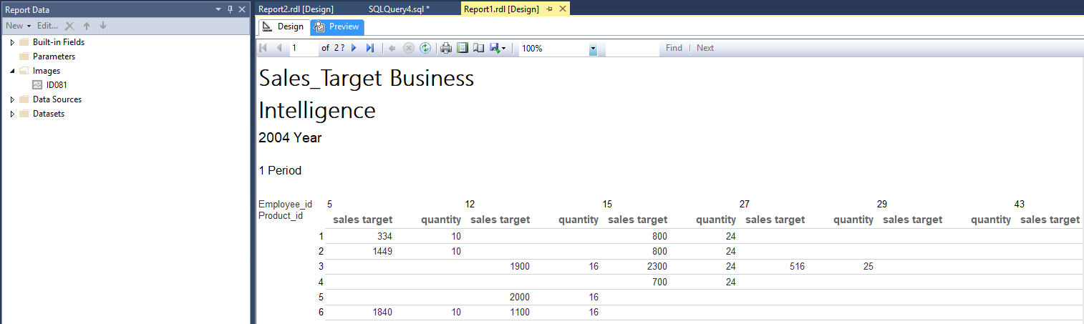

*Afbeelding 14: Query rapport 1*



*Afbeelding 15: Rapport 2 in SSRS tool*

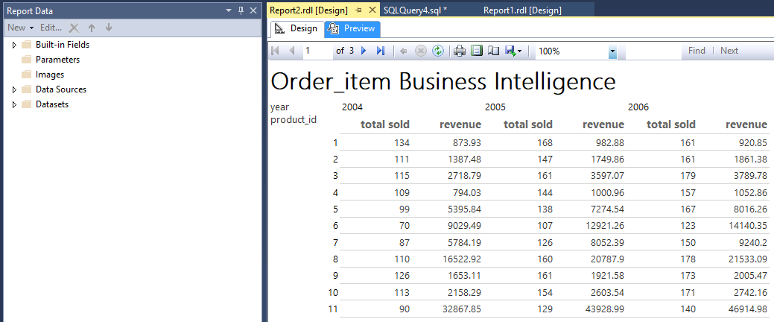

*Afbeelding 16: Query rapport 2*

